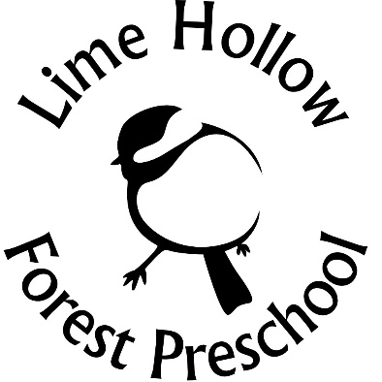

Lime Hollow Parent Consent Agreements

Child’s Name (please print):______________________________ is now enrolled in Lime Hollow’s Forest Preschool and Lime Hollow has received the following documents to include this form:

• Registration form
• Medical and emergency contact form
• Health plan if needed
• Signed consent agreement (this form)
• A copy of your child’s immunization record or proof of religious exemption
• Questionnaire form

Initial each statement and sign the bottom.

Permission Waivers:
I give permission for my child’s photo/video to be used in promotional/educational/social media. ______
I give Lime Hollow Staff permission to reapply sunscreen, bug spray on my child if needed.______
I give permission to Lime Hollow Staff to transport my child by ambulance, personal vehicles. This includes emergency situations and or evacuations._______

Parent Handbook/Tuition/Behavior Waiver:
I have read and studied the Preschool Parent Handbook. _____

I am aware of our payment for the year and know that I am responsible for paying for the full year. If my child drops out, I know that we are responsible for the full year tuition unless Lime Hollow can find another preschooler to take our spot._____

I understand that Lime Hollow Forest Preschool reserves the right to cancel this contract at any time if the staff finds that the program is not suitable for my child due to repeated, unacceptable behavior and that any refund will be at Lime Hollow’s discretion._____

I realize that lack of adherence to these policies may result in early termination of the Forest Preschool Program. ______

Outside Field Trip Waiver
I give the Lime Hollow Forest Preschool staff permission to take my child out on the trails fully supervised for a portion of the day, everyday. While my child is outside, I understand there are hazards of outdoor activity to include, but are not limited to:
- Injuries from physical activities
- Injuries from failing to properly use tools such as carving knives and or fire
- Exposure to weather and water
- Exposure to wildlife such as the local amphibians and reptiles
- Contracting poison ivy
- The presence of ticks and of exposure to tick-borne illnesses. I know Lime Hollow staff will be removing embedded ticks if they are found.

_______

Emergency Waiver
In an emergency, when the undersigned or other named person cannot be contacted, I hereby authorize the Forest Preschool Director to take any action deemed necessary for the best interest of my child.______

Liability Waiver
Lime Hollow Forest Preschool staff will exercise many cautions to prevent mishaps (including adequate adult supervision, extreme care in potentially dangerous situations, clear communication with children), injuries are still possible. Provided adequate precautions have been taken by Lime Hollow staff, I will assume all risks of injury, hereby releasing and holding Lime Hollow harmless along with their employees from liability for any such injury
It is also the parent’s responsibility to update Lime Hollow with any changes prior to the start of Forest Preschool.

This form needs to be completed prior to starting the Forest Preschool Program
Parent/Guardian Signature_______________________________ Date____________

Parent/Guardian Signature_______________________________ Date____________
