Family Handbook
2018-2019

Welcome to Little Leaf at Andrus-on-Hudson!
Our Mission
To create a learning environment that nurtures a child’s mind and body and respects the wonder and magic of early childhood.
To provide a daily experience that emphasizes play, social / emotional learning and a connection to the natural world.
To dive into long-term studies based on an emergent curriculum inspired by Reggio Emilia, Waldorf, and Coyote Mentoring approaches
To align our work with important environmental standards and create stewards of the planet and young naturalists
To create a strong inter-generational community of educators, parents, children and grands

Staff Directory
Director and Nature Teacher
Theresa McCaffrey, tmccaffrey@littleleafschool.com

Administrative Assistant and Engineering / Nature Playscape Consultant
Nina Horozova, littleoffice@littleleafschool.com

Acorn Class
Head Teacher: Amy Milano, amy@littleleafschool.com Phone; 914-260-2998
Assistants: Cecilia Lemus and Sarina Eshtiaghi

Sugar Maple Class
Head Teacher: Allison Griffin, ali@littleleafschool.com Phone: 917-501-2990
Assistants: Nina Horozova and Cristina Silva

Sassafras Class
Head Teacher: Monica Della Croce, monica@littleleafschool.com Phone: 914-645-3500
Assistants: Jake Sacket and Donna Soszynski

Intergenerational Program Coordinator, founder of Roots and Sprouts
Joanne Corrigan

Andrus-on-Hudson
185 Old Broadway
Hastings-on-Hudson, NY 10706
Phone: 914-478-3700
Executive Director: Betsy Biddle
Director of Development: Judith Knispel (collects donations!)

Contact Us Here with Dismissal Changes and Time Sensitive Information:
Landline: 914-478-3700, ext. 845
Google phoneline: (914) 418-4541
Theresa’s cell phone: 646-489-7757

School Calendar 2018-2019
Aug 27 – Sept 6: Professional Development (Teachers Only)
Sept 5: Acorn Class Back to Nature School Night
Sept 7: Family Visiting Day
Sept 12: 1st Day of School
Sept 12: Sugar Maple and Sassafras Class Back to Nature School Night
Sept 15: Garden Family Potluck at 10 AM
Sept 19: School Closed, Yom Kippur
October 8: School Closed, Indigenous People’s Day
Nov 6: School Closed, Professional Development
Nov 12: School Closed, Veteran’s Day
Nov 21: Half Day
Nov 22, 23: School Closed, Thanksgiving Break
Dec 13: Half Day, Parent – Teacher Conference
Dec 21: Winter Solstice Lantern Walk
Dec 24 – Jan 1: School Closed, Winter Break
Jan 21: School Closed, MLK Day
Feb 18-22: School Closed, Mid-Winter Break
March 22: School Closed, Professional Development
April 15-22: School Closed, Spring Break
April 28: Springfest at Andrus on Hudson
May 24, 27: School Closed, Memorial Day
June 14: Last Day of School

Little Leaf Class Hours
Monday – Friday
Acorn Class: 9:15-12

Sugar Maple Class:
9:00-12 (morning session)
9:00-2:30 (full day session)

Sassafras Class:
8:45-11:30 (morning session)
8:45-2:15 (full day session)

The First Days in the Acorn Class
Amy has been in touch with all of you regarding your child’s schedule and expectations for the first few weeks. If you have any questions, do not hesitate to reach out. Enjoy your home visits and making your child’s All About Me books!
The First Days in the Sassafras Class and Sugar Maple Class
The first day of school is Wednesday, September 12th for children who attend Little Leaf on Wednesdays in the Sugar Maple and Sassafras classes. Thursday, September 13th is the first day for students who attend on Thursdays. We plan to have full days on these first days (for the children who are signed up for full days.) During these first weeks, if your child has a difficult time separating, you may choose to stay. Chairs will be placed on the outskirts of the garden and classrooms for parents or caregivers. I encourage you to bring a book and spend some quiet time with us. I ask that parents allow children to explore and play on their own knowing that a parent or caregiver is close by. At times, your child may choose to play nearby or sit on your lap which is fine. Please refrain however from playing with your child in the play space as this may be confusing for the children. The teachers will connect with each of you to discuss a departure plan. If you believe your child will not need your presence on the first day of school, I encourage you to bring them to school, give them a hug, and leave them to discover their play space and friends.
Please bring the following on the first day of school:
- 1-2 changes of clothes including underwear and socks in a labeled Ziploc bag.
- Lunch – if your child stays for the full day (see lunch section)
- Rain gear – if it is raining (see gear section)
- Slippers / inside shoes to keep at school
- Diapers and wipes if your child is in the Acorn Class
- Cot Linens (if your child naps – see napping section for more details)

If you would like to contribute to our general class supplies, any of the following items would be greatly appreciated. We use the brands Seventh Generation, Babyganics, Whole Foods, or Meyers:
Baby wipes, brown paper towels, dish detergent, tissues, surface cleaner and a natural ingredient hand sanitizer

Arrival and Dismissal Protocols
Once children are settled at school, parents / caregivers should drop-off and pick-up the children in the traffic circle. This year we have two waiting benches where children can wait with supervision. You may choose to park and walk your child to the garden. If you do, be sure your car is parked in the lower level parking lots. Please wait until the set start time before entering the garden (which is our outdoor classroom) so teachers have ample time to set up for the day.
Barring any crazy circumstances, please arrive on time in the AM. Late arrivals disrupt the flow in the classroom and make it harder for children to transition to school.
After school, please pick your children up on time. If you are running late, call the school landline or send a text to your child’s head teacher. If you are continually late, a late pick-up fee will be charged. We can offer you a 5-minute grace period most days but being consistently late is problematic.
Morning Goodbye Routine
I encourage you all to create a goodbye routine with your child that is consistent. Once the first weeks of transitioning are complete, for the children in the Sugar Maple Class and the Sassafras class, we ask that you say goodbye to your child at The Waiting Benches. Lingering in the garden or classroom makes goodbye a confusing time and can be disruptive to the group.
Please communicate with the staff if you have a special request for arrival or dismissal.
If your child will be picked up by someone other than you or your designated caregiver, you must share this information with a teacher or assistant. Please note that your child will not be dismissed with anyone without direct permission from a parent.
Lunch
If your child stays at Little Leaf for the full day, please send lunch in a sealed and labeled bag (like a lunchbox.) Label all containers and include utensils and an ice pack if you wish the food to remain cold. Refrain from using disposables such as plastic Ziploc bags, tin foil and juice boxes as we strive to be a zero-waste school. Include a reusable water bottle. Currently, children may bring nut butters to school. We will let you know if this changes once we receive all medical forms.
Any uneaten food will be returned home and lunch bags will be sent home at the end of every day. Our staff will help the children during lunch to open containers and will assist them in any way.
Naps
If you have indicated that your child will nap on the napping agreement, please send in linens for nap time. Children will sleep on cots designated for them. They will need any or all of the following: sheet, blanket, pillow, stuffed animal. Please label everything and send linens in a plastic bag. We will send all linens home on Fridays to be washed. Children will nap in a quiet area supervised by a staff member starting at approximately 1 PM.
Communication
We believe that communication with families is key to the success of our program and your child’s experience. We use email, text and phone and can schedule meetings with you. We prefer to communicate during normal school hours or during meetings that have been previously agreed upon.
We will also share lots of photos and narratives of our learning experiences in the family newsletters every two weeks. We will hold one “official” parent / teacher conference during the year in December (see calendar.)
Nature walks and the new forest classroom
Nature walks and wild play are at the heart of our programming! On a daily basis, classes will walk (or skip or hop) to the Great Hill, the Acorn Ice Cream Shop (not really an ice-cream shop,) the Maple Tree Grove and the Totem Pole Castle on the Andrus-on-Hudson property to play and explore. Each season offers us different learning opportunities – one of my favorites is tapping the Maples in February and March.
This summer we worked with Arborpolitan, a local tree company whom I highly recommend, to create a forest classroom called The Spruce Grove. Theresa will be the resident nature teacher this year leading each class on at least one nature adventure per week often to the Spruce Grove for loose parts play and nature studies.
Our Milestone Tradition

The Milestone Walk is a special journey that our kindergarten-bound graduates undertake on their last day as a preschooler at Little Leaf. The children walk from our garden to the Great Hill by way of The Maple Tree Grove – a nature walk they have completed many times - but this time without a teacher. For us, this is about honoring milestones and transitions, filled with independence and self-reliance. The walk is connected to their days at Little Leaf spent orienting themselves to the land, playing in the forest, collecting treasures and connecting to nature and each other. We pair the children up with milestone buddies and they walk in groups of 2 or 3 children. We greet them at the bottom of the Great Hill with song and lots of hugs.

Intergenerational Programming
Part of our mission is to form connections with the residents who reside at Andrus-on-Hudson. We take baby dolls for walks upstairs, sing in the lobby, and try to infuse the building with nature and fun. Last year, we had an intergenerational fashion show, a seed planting party, and a group who lunched daily with the grands with our Intergenerational Coordinator, Joanne Corrigan. The seniors who reside at Andrus-on-Hudson may also spend some time with us in the garden and classrooms.
Children are always supervised by Little Leaf staff members and are never alone anywhere in the building. Children stay together and are instructed never to run in the hallways (we often tip-toe like mice.) Little Leaf staff members wear Andrus-on-Hudson badges which can open the stairwells.
If children are attending programming on the first floor, we use the stairs. If children are going to the 2nd-5th floors, we take the elevator. The elevator inspection certificate is on file.
We work directly with the Community Life department at Andrus-on-Hudson. They are always in need of volunteers. Please contact Leslie Hoot, the director, at lhoot@andrusonhudson.org if you are interested in donating some time to the nursing home.
Birthdays
If you would like to celebrate your child’s birthday at school, please send a healthy treat to share such as fruit or homemade pie or muffins. Your child’s head teacher will coordinate this with you and let you know if there are any allergies in the class. Family members may attend our birthday celebrations.
Parent Gatherings
There will be several parent gatherings throughout the year at Little Leaf. We hope you will join us! We will kick off the year both with our Back to Nature School Night and our Saturday Morning Family Potluck. We will also celebrate the winter solstice with a Lantern Walk in December, a family hike to celebrate the first day of spring, and an end-of-year garden / forest party at the end of June.
Gear Requirements
In this section, we recommend certain brands. Please note that we do not require certain brands, only certain gear.
Clothing:
Children should be dressed in comfortable play clothes, so they can climb and jump and get dirty They should wear washable clothes which they can handle themselves. Please use elastic waist pants when possible and refrain from allowing your children to wear long skirts as they tend to be unsafe when climbing, jumping, running, etc.
Shoes:
The type of shoe your child wears at nature preschool is very important. Please use shoes that provide good support. Sandals must have a strap across the back of the foot and not be open-toed. Flip-flops and Crocs are not acceptable for safety reasons. Sneakers or hiking shoes with Velcro closures are great.
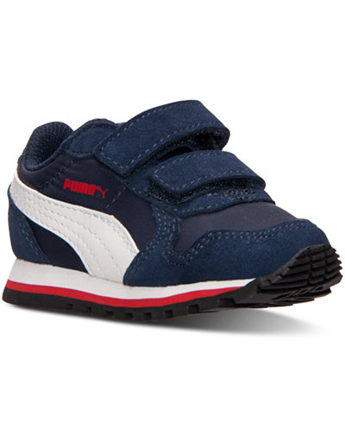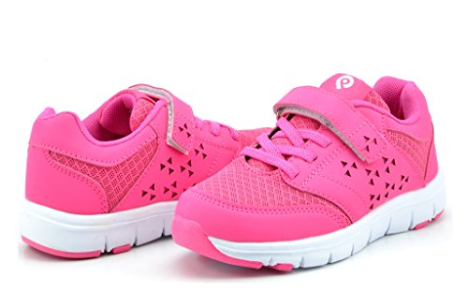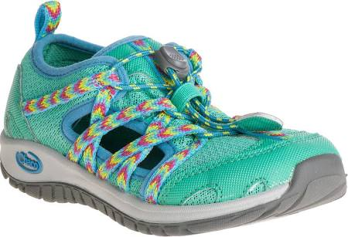
When purchasing boots choose ones that are easy to put on, preferably with pull handles. Go for warmth, waterproof, good support, easy to put on and not too heavy. Some recommended brands are Bogs, Kamik, Keens, Merrill and Lone Cone.
Rain Gear:
Some recommended brands: Land’s End, Oakiwear, Polaryn
Please be sure your child has the following and wears them to school on rainy days. Children and teachers play in the rain at Little Leaf and there is no option for children to remain inside. If your child arrives without gear, you or your caregiver will need to go home and get it as we cannot have one child remain inside while others play outdoors.

If you have boots, rain pants, or rain coats to donate, please send them in for our Borrow Baskets.
- rain pants or overalls
- rain jacket with a hood
- rain boots
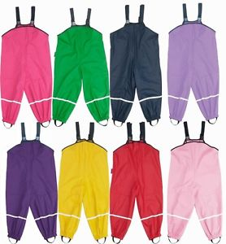

Winter Gear:
Children need warm waterproof snow boots, snow pants, a winter coat, a hat and gloves every day in the winter.

Indoor shoes:
Please send a pair of simple shoes or slippers for your child to wear indoors.

Personal Toys
Personal toys should be left at home or in the car. Such items are often lost and present a problem for the children.

Snacks
Snacks will be provided by Little Leaf and will be fruits and vegetables, whole grain crackers and rice cakes. Children will drink water or herbal tea. If you’d like to provide a healthy snack for the class on any given day, please let us know. We always appreciate fruits and veggies. Children will often participate in snack preparation and the teachers may incorporate different healthy snacks.
Allergies
If your child has any allergies, please be sure to request a Special Needs Health Form and bring in your child’s Epi Pen if he / she requires one.
Toilet Training
Children in the Sassafras and Sugar Maple classes are expected to be toilet trained, or at least actively working on the process. If you are concerned about this, please speak to your child’s head teacher.
Forms
We are required to have certain forms and information in your child's file including a yearly medical form. The immunization record must be filled out and returned before your child can attend school. Each form is valid for one year. Please update your child’s medical forms as you visit the pediatrician.
Illness Policy

If your child will be absent, please send an email to your child’s head teacher. It is especially important to let us know if your child has something contagious, so we can let our school community know.
Children with diarrhea, bad coughs, colds, fevers, heavy nasal discharges, green or yellow eye discharge or vomiting must be kept home until the symptoms disappear. If your child has been diagnosed with the flu or has flu symptoms (fever of more than 100 F accompanied by other flu symptoms such as aches, cough, sore throat, etc.), your child should be kept home for at least 24 hours after the symptoms resolve.
Please do not send your child to school if you suspect they are ill. If your child cannot play outside because of illness, he/she should stay home.
On occasion, a child may become ill while at school. Little Leaf’s policy is to notify the parent and request that the child be picked up at school as soon as possible.

Ticks

We will perform a tick check at the end of our morning together of the easy to see places - but please remember to perform a more thorough tick check at home every day. This is a link to a daily tick check card you can print out: http://www.tickencounter.org/ticksmart/daily_check_card.
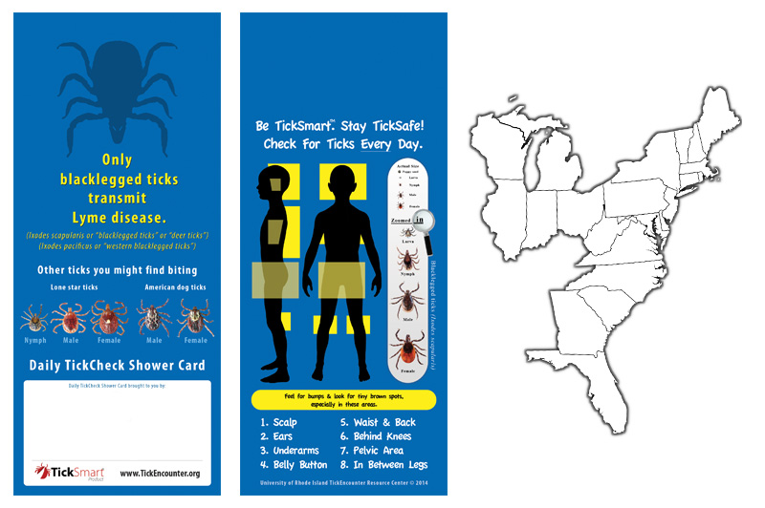

Emergency Closings
For school closings caused by inclement weather, Little Leaf will follow the Hastings-on-Hudson school closure status (https://www.hohschools.org/hillside). We will send out a group text and e-mail in the AM if Little Leaf will be closed.
Professional Licensure and Requirements
Little Leaf is licensed by the Office of Children and Family Services and must comply with NYS small daycare regulations. These regulations cover issues such as health and safety protocols, staff to child ratios, and staff training requirements. These regulations can be found here: https://ocfs.ny.gov/main/childcare/daycare_regulations.asp
As part of our licensing program, we must practice monthly fire drills and two shelter-in-place drills each year. A record of these drills is kept on-site. In the event we must evacuate the building and the grounds, our relocation site is Theresa McCaffrey’s house at 24 Crossbar Road in Hastings, a 5 minute walk from Andrus on Hudson. Parents will be notified immediately via phone and email.
Staff Training
All staff at Little Leaf are CPR and First Aid certified. Staff are required to attend a minimum of 15 hours of training per year. At Little Leaf, we tend to surpass that requirement attending lots of conferences and workshops in the nature preschool and early childhood communities. We are a school member of the Eastern Region of Forest Kindergartens and Nature Preschools as well as the Natural Start Alliance. We also visit other preschools throughout the year and host teachers from other schools as well.
Tuition

Families will receive an invoice with the annual tuition broken up into two payments. Your deposit will be deducted from the first tuition request. Tuition can be paid via check to Little Leaf at Andrus-on-Hudson or through Chase QuickPay.

Families are responsible for all payments for the entire year. We understand that some of our families may be required to leave the area on short notice prior to the end of the school year. We will only issue a refund if you are moving out of the area. The following refund schedule will be used if a family has paid their tuition in full:
- Families that leave by January 1st will receive two (2) months refund if all tuition has been paid.
- Families that leave by February 1st will receive one (1) month refund if all tuition has been paid.
- Families that leave after February 1st will not receive a refund.

Families will be charged a $35 late fee if tuition payments are more than 7 days late.

Parking
Parking in the AM at Andrus-on-Hudson is usually not an issue. There are visitor spots in the lower level parking lot. Mid-day parking can be a bit more difficult. We are here to help you so if you ever have trouble parking, please call or text one of the teachers. During pick-up, you may leave your car along the outer fire lane – not around the island in the middle – as long as you can see it and get to it fast in the event that it needs to be moved. Please remember that Andrus-on-Hudson is a medical facility. Residents may need quick medical attention and we never want our cars to be in the way. The folks at Andrus on Hudson who so graciously share their parking circle with us will be fined from the town if cars are all over the place in the circle, and you will consequently receive a ticket. Please share this information with your caregivers!!!!
There is currently a valet at Andrus on Hudson. If you are really stuck, give your car and keys to the valet.
We are counting on our parent community to help enforce these rules. If someone is out of compliance, please tell them to park elsewhere (politely, but emphatically!) If you’d like to volunteer to be a parking monitor, let us know.

Please Do Not:
Double park in the traffic circle
Park around the island in the middle of the traffic circle
Block cars
Engage in rude parking behavior

Discipline Policy

We use positive reinforcement and acknowledge and validate each child’s emotions. We investigate conflict with the children to understand all perspectives. We see “conflict” as a normal part of childhood (and life!) and help the children navigate by offering choices and appropriate language. Teachers will often “hang back” if children are working through a conflict and only intercede if they appear to need assistance.

We use intentional language with the children. Instead of general praise (i.e. Good Job!) we are specific about a child’s work, i.e. “You used many colors in your painting,” or “You tried hard to work through that problem.” Instead of saying, “I love your painting!” which sets children up to seek out external praise, we might say “You added so many details to your picture.” We do not make children “say sorry” but instead request that children acknowledge what may have been inappropriate behavior and listen to others’ feelings and thoughts if other children were involved. If they choose to say sorry, we want it to be authentic.

For inspiration, our staff turns to the book “How to Talk So Little Kids Will Listen” by Joanna Faber and Julie King.

Any form of corporal punishment, hitting, abusive language, ridicule, or harsh, humiliating, or frightening treatment is absolutely prohibited at Little Leaf and is not tolerated. A child may be separated from the group if their actions pose a safety issue to other children or if their behavior is incredibly disruptive to the group. A child will then work with an adult to self-regulate before rejoining the group.

Children who are continually causing difficulties often need extra help. In these instances, we may:
- hold meetings with parents, teachers and the director
- advise parents of available professional evaluation options
- help families connect to outside professionals

We will not allow children to strike, bite or kick each other or a teacher or to destroy property. In the natural world, this means we will not permit children to kill wildlife (including insects,) break branches off living trees, or pull up grass.

Little Leaf reserves the right to request the removal of a child. Such a request will be made if it becomes apparent that the safety and well-being of children or staff members are in jeopardy. Little Leaf may also make this request if it appears that our program is not a good match for the child or family.

To prevent discipline issues, we always provide adequate supervision, offer stimulating activities and ample time for free play and projects, distract, humor, offer notice when activities are close to ending, and meet as a team to decide on best practices for certain behaviors and situations. We require children to participate in clean up rituals and strive to make “chores” fun.

Please let us know if you have any questions. We look forward to a wonderful year and are delighted you have chosen Little Leaf at Andrus-on-Hudson for your child.

I, ________________________________________, acknowledge that I have received a digital copy of Little Leaf at Andrus-on-Hudson’s Family Handbook. I acknowledge that I have read the handbook in its entirety and will abide by the policies outlined within the document. In addition, I understand that the contents of the Family Handbook are subject to change. I acknowledge that the Parent Handbook will be revised in accordance with the rules or regulations of state, federal, and accrediting entities, best practices for child care service providers, or at the discretion of the director of Little Leaf at Andrus-on- Hudson. I recognize that it is my responsibility to contact the Director with any questions I might have about the contents of the Family Handbook now and in the future.
By initialing next to each of the bulleted points below, you signify that you have specifically paid close attention to the following sections of the Family Handbook:
- Illness Policy ______________ (Initial)
- Gear Requirements_____________ (Initial)
- Arrival and Dismissal Protocols _______________ (Initial)
- Tuition _______________(Initial)

Both parents / guardians, if applicable, MUST sign and date this form.

_________________________________________ ____________________________________
Signature Printed Name
_________________________________________ ____________________________________
Signature Printed Name
_________________________________________ ____________________________________
Date Date
________________________________________________ Child Registered in Program (1)
_________________________________________________ Child Registered in Program (2)

